SOVAN LAL SAHA

AWS Solution Architect & Data Architect
EMAIL : sovanlalsaha@gmail.com MOBILE :+919819308298

LINKEDIN
www.linkedin.com/in/sovan-saha-3b68959a



An enthusiastic & high energy-driven IT professional, targeting challenging assignments as AWS Cloud Solution Architect/Data Architect with an organization of high repute across IT industry

Preferred Location: Kolkata, Bangalore, Hyderabad, Mumbai, Delhi and Pune

PROFILE SUMMARY

- AWS Solution Architect & Data Architect with high integrity offering 17.5 years of experience in understanding the business requirement, analyzing the technical requirement and architecting end-to-end cloud solutions
- Design and implement cost-effective and secure cloud architectures on AWS using VPC, EC2, RDS, IAM, EBS, EFS, S3, Glacier, CloudFront, Aurora, DynamoDB, Redshift, Glue, Lambda, API Gateway, SQS, SNS, CloudWatch, CloudTrail, Cognito, WAF, Route 53, Kinesis, ELB, Auto-scaling etc.
- Adept in end-to-end AWS infrastructure management, including provisioning and overseeing EC2 instances, configuring networks, managing data storage, and establishing databases. Skilled in leveraging AWS Systems Manager for seamless patching processes, enhancing security measures, and contributing to the optimal performance of hosted systems and services
- Analyze Software Requirement Specifications (SRS) and Low-Level Design (LLD) documents to design and implement databases that meet the business requirements
- Use Erwin data modeler to create logical and physical data models based on the SRS and LLD, ensuring the database aligns with the architecture of microservices, supporting modular and decoupled application development
- AWS FinOps: Achieved significant cost reductions through strategic optimization and efficient resource management. Implemented Spot EC2 instances for non-critical workloads, achieving up to 50% cost savings while maintaining performance and reliability
- Hands-on experience working in OLTP/OLAP/Data Warehouse databases like Oracle, SQL Server, Postgres, Amazon Redshift, DynamoDB and so on
- Technical understanding of data models, data management concepts and associated business processes and tools, specifically Data Governance, Master Data Management, Data Modeling, Data Quality, Database Design & Development, Data Pipeline, Data Integration (ETL) between different systems, data lake, data warehouse
- Proficient in developing and modifying triggers, packages, functions, and stored procedures for efficient data conversions. Specialized in utilizing PL/SQL procedures to dynamically create database objects based on user inputs, showcasing a keen ability to tailor solutions to specific requirements and enhance overall database functionality
- Track record of cloud migration of large-scale IT programs, taking ownership of the cloud architecture & design activities and outputs; successfully migrated the legacy systems from on-premises to AWS Cloud
- Proficient in providing technical design and architectural leadership to multiple multi-geographic teams & projects; insightful experience in program management activities including scoping, estimation, planning, risk management, finalization of technical/functional specifications, resource administration & quality management
- Proven success in acting as a Delivery Anchor for new deals with understanding of a variety of popular technologies in the space of AWS Data services
- Experience in all phases of Software Development Lifecycle which includes software analysis, design, development, testing, implementation, debugging, maintenance & documentation of client/server, Internet, Web-based applications
- Took the lead to spearhead end-to-end Cloud Operations for facilitating support to infrastructure post migration; worked closely with the client/ partner teams including Sales, BD teams, and external clients
- Crafted integrated AWS Cloud Solution & roadmap, with clear understanding of other phases of application cloud migration lifecycle like Testing, Integration, took relevant assumptions and highlighted the risks
- Insightful experience in ensuring that critical applications are designed and optimized for high availability and disaster recovery
- Experience in seeking the alignment of business & IT, operating across organizational and technology teams to adopt cloud services, with common approaches, delivering sustainable, agile and re-usable solutions
- Thought leadership and team-building skills, and capability to collaborate effectively with a group of high performing individuals



CORE COMPETENCIES

AWS Cloud Architecture |   AWS Infra Management |   Datawarehouse & BI
Data Architecture |   Cloud Migration |  Data Governance
Data Modeling |   App Modernization |  Data Security and Backup
Database Development  Data Integration & ETL |   Cloud Cost Optimization |  Microservice Architecture




 CAREER TIMELINE

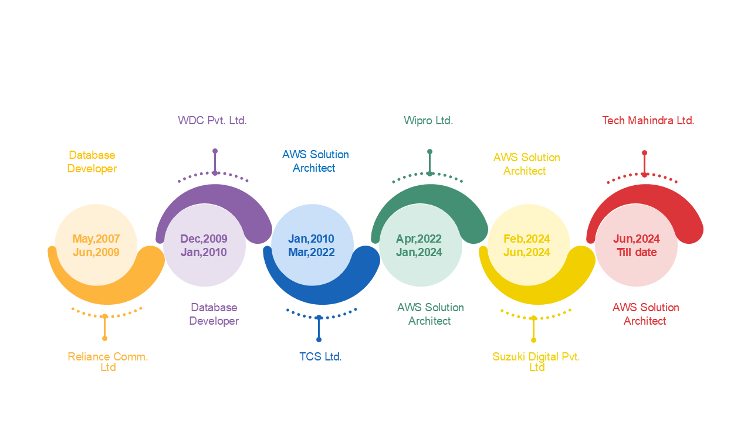

 TECHNICAL SKILLS

- AWS Cloud Services:
Compute: EC2, Lambda, ECS Storage: S3, EBS, EFS, Glacier, FSx
Databases: RDS, Oracle, SQL Server, DynamoDB, Redshift, Aurora, ElastiCache
Migration & Transfer: Migration Hub, Database Migration Service (DMS), Schema Conversion Tool (SCT), App Migration Service
Networking: VPC, CloudFront, Route 53, ELB, API Gateway, Direct Connect, Transit Gateway, VPN Management and Governance: Control Tower, Lading Zone, System Manager, Patch Manager, Service Catalog, CloudWatch, CloudTrail, Cost Explorer, Cost Allocation Tags, Trusted Advisor, AWS Organizations
Security & Identity: IAM, Cognito, WAF, AWS Shield, KMS, Secrets Manager, AWS Certificate Manager, GuardDuty, Security Hub
Application Integration: SQS, SNS, Kinesis, EventBridge, Step Functions ETL: Glue, Data Pipeline, AWS Lake Formation
Developer Tools (CI/CD): CodeCommit, CodeBuild, CodeDeploy, CodePipeline

- Tools: Erwin Data Modeler, GitLab, GitHub, Confluence

- Databases: Oracle, SQL Server, Postgres, Redshift, DynamoDB
- Languages: SQL, PL/SQL, Unix Shell Script, HTML, JavaScript, XML, Core Java, Python

WORK EXPERIENCE

Since Jun’24 with Tech Mahindra Ltd., Gurgaon as AWS Solution Architect

Key Result Areas:

- Design scalable and secure data architecture on AWS, integrating Aurora databases with microservices to support logistics operations such as shipment tracking, vehicle management, and route optimization
- Analyze Software Requirement Specifications (SRS) and Low-Level Design (LLD) documents to design and implement Aurora databases that meet the requirements of logistics microservices
- Use Erwin to create logical and physical data models based on the SRS and LLD, ensuring the database aligns with the architecture of microservices, supporting modular and decoupled application development

Feb’24 to Jun’24 with Suzuki Digital Pvt. Ltd., Gurgaon as AWS Solution Architect

Key Result Areas:

- Designed and implemented AWS ECS-based microservices architecture for scalable applications
- Migrated on-prem workloads to AWS Lambda-based serverless architecture, reducing operational costs by 40%
- Optimized DynamoDB tables with on-demand capacity mode, improving read/write efficiency
- Developed Terraform modules for automating ECS cluster deployment and VPC networking
- Implemented AWS Step Functions to orchestrate multi-step business workflows
- Secured APIs using AWS API Gateway, Cognito authentication, and IAM roles

Apr’22 to Jan’24 with Wipro Ltd., Kolkata as AWS Solution Architect

Key Result Areas:

- Exhibiting excellence in managing the entire SDLC (Software Development Life Cycle) process from analysis, design, development, testing, implementation, and maintenance with on time delivery
- Playing a significant role as a team member and demonstrated success over designing, building and migrating applications, software and services on the AWS platform
- Played a pivotal role in overseeing the entire spectrum of AWS infrastructure management. Successfully provisioned and managed EC2 instances, configured complex networks, managed storage solutions, and set up databases
- Designing and implementing public and private facing websites on AWS Cloud
- Leading the implementation of Cloud Solutions using various core AWS Services including EC2, AWS RDS, DynamoDB, Redshift, Glue, AWS Lambda, API Gateway, Amazon SQS, Amazon SNS, VPC, S3, Cloud Watch, Cloud Front, Route 53 and so on
- Governing work with OLAP/DW databases such as Oracle, SQL Server, Postgres and so on; writing complex PL/SQL procedures, packages, triggers, function, queries
- Conducting performance tuning on OLAP and OLTP database
- Facilitating the appropriate selection of Cloud services to design and deploy an application based on given requirements; offering recommendations to optimize Cloud usage costs by analyzing usage patterns and use cases
- Engaging in architectural discussions and design exercises to create large scale solutions built on AWS
- Mapping and focusing on customer centric solutions; driving discussions with senior personnel regarding trade-offs, best practices, project management and risk mitigation

Jan’10 to Mar’22 with TCS Ltd., Kolkata as AWS Solution Architect

Key Result Areas:

- Spearheaded the entire gamut of designing, development, management scalability, highly availability, secured and fault tolerance system on AWS; engaged in the full development cycle of planning, analysis, design, development, testing, and implementation
- Worked on Application Migration project from On-premises to AWS Cloud; managed Migration planning, AWS architecting, configuring and securing the infrastructure on AWS Cloud
- Transformed and transitioned applications to AWS Cloud and modified its architecture by taking full ownership of cloud-native features to improve agility, performance, fault tolerance and scalability
- Worked on the changeover from an existing system to a new one and ensured improved version to work with existing systems
- Implemented Cloud Solutions with primary AWS services (EC2, ELB, RDS, DynamoDB, Lambda, API Gateway, Route53 & S3)
- Functioned with OLAP/DW databases such as Oracle, SQL Server, Postgres and so on; created and modified SQL Plus, PL/SQL and SQL Loader scripts for data conversions
- Developed and modified triggers, packages, functions, and stored procedures for data conversions and PL/SQL procedures to develop database objects dynamically based on user inputs
- Wrote SQL, PL/SQL, SQL Plus programs required to retrieve data using cursors and exception management
- Designed indexes on tables to enhance the performance by eliminating the full table scans and views for hiding the actual tables and to eliminate the complexity of the large queries
- Collaborated closely with the front-end design team to provide the necessary stored procedures and packages as well as insights into the data
- Created and modified several Unix shell scripts according to the changing needs of the project and client requirements

Dec’2009 to Jan’10 with WDC Pvt. Ltd., Pune as Database Developer

Key Result Areas:

- Designed and optimized complex queries for high-performance applications
- Developed PL/SQL stored procedures, triggers, functions, and packages for business logic implementation
- Improved query performance by 50% using indexing, materialized views, and caching techniques
- Built ETL workflows to load and transform data from multiple sources
- Created database partitions to enhance query performance for large datasets
- Automated data processing tasks using PL/SQL jobs and scheduling mechanisms

May’2007 to Jun’09 with Reliance Comm. Ltd., Mumbai as Database Developer

Key Result Areas:

- Developed highly optimized SQL queries and stored procedures for reporting and analytics
- Designed PL/SQL packages to implement complex business logic for financial transactions
- Collaborated with DBA teams to fine-tune database performance and ensure high availability
- Created and maintained ER diagrams, logical/physical data models

SOFT SKILLS

Change Agent
Collaborator Communicator Innovator
Planner Thinker

EDUCATION & CERTIFICATIONS

AWS Certified Solutions Architect - Associate Validation Number 8CHJG8YLGMF1QKKX Validate at: https://aws.amazon.com/verification

AWS Certified Cloud Practitioner
Validation Number CSQ4CQ32JM111BKC
Validate at: https://aws.amazon.com/verification

Bachelors in Electronics and Communication Engineering from Dr. B.C.Roy Engineering College, 2006


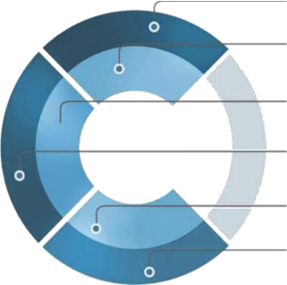



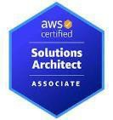
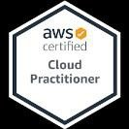

PERSONAL DETAILS
Date of Birth: 15th October 1980 Languages: English, Hindi and Bengali Address: Kolkata

